E-Resources provided through VTU Consortium
E-books | E-Journals
  https://www.expresslibrary.mheducation.com/ |   https://ieeexplore.ieee.org/Xplore/home.jsp

https://link.springer.com/
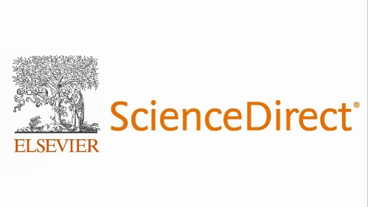
https://www.sciencedirect.com/
  https://www.taylorfrancis.com/ | https://www.tandfonline.com/
  https://digital.elib4u.com/ | 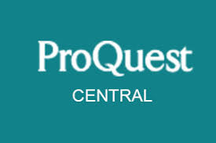  https://www.proquest.com/
  https://videeya-in.sjbit.mapmyaccess.com/ |   https://www.emerald.com/insight/
  https://sjbit.mintbook.in/ | https://www.emerald.com/insight/content/case-studies
  Remote Access  https://sjbit.mapmyaccess.com/resources | 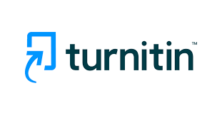  Plagiarism Check Tool  https://turnitin.com/
Other E-Resources
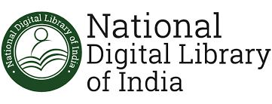  https://ndl.iitkgp.ac.in/ |   http://164.100.247.26/

